TECH 3812
Lab #1
Ladder Logic
2020 V1.1
Name:________________________________
Using PLC Fiddle create a Motor Start/Stop pushbutton station as we discussed in class.
Everything will run in the browser. There is no software to download and install.
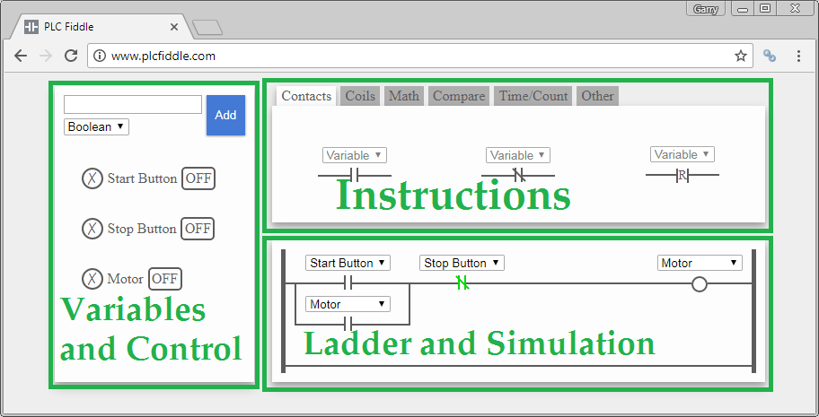
The software has three main parts as illustrated above. Variables and control, Instructions, Ladder and Simulation make up the main parts of the program. It is important to understand each of these components.
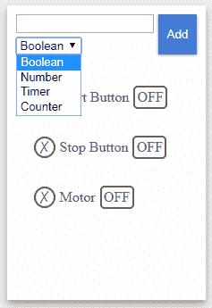
Variables and Control
This is where we can add Boolean (On/Off, Discrete), Numbers, Timer or Counter variables to our PLC program. You select the type and then give it a name. The new variable will appear in the list below. The X to the left of the variable will allow you to delete it. The status of the variable will appear to the right.
You can use your mouse to also click and change the variable. Example: Click the ‘OFF’ button and it will then turn ‘ON’.

Instructions
The instructions have several different tabs. These contain all of the different items that you can use in you PLC logic or methods. Let’s review the instructions tabs.
Contacts:
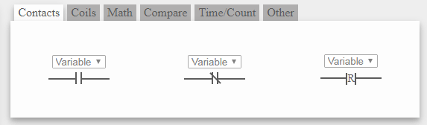
Normally Open, Examine On, Normally Closed, Examine Off
Coils:
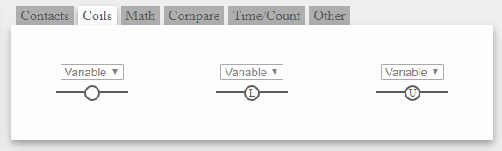
Output, Latch, Set, Unlatch, Reset
Math, Compare, Time/Count:
These are advanced PLC functions and will be covered in your PLC class next semester
Other:
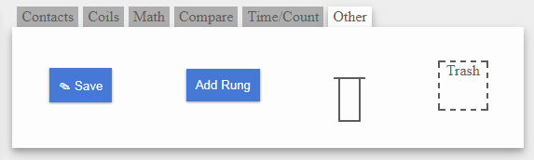
Save – Save your project with a unique URL.
Add Rung – Add a rung to the bottom of the current program.
Branch Circuit – Add an ‘or’ logic branch to your program (this is usually referred to as a branch rung).
Trash – Allows you to delete items from your PLC logic (Drag a component off the ladder logic to the trash box to delete).
Ladder and Simulation
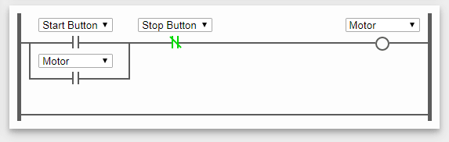
This area is where you will build and monitor your logic in action. This is controlling a motor from the start and stop pushbuttons which are wired up as physically normally open. (This is why the stop button is shown as a normally closed contact.)
Create the following Motor Start/Stop pushbutton ladder logic as shown below use your initials as part of the motor name (IE Motor_DK):
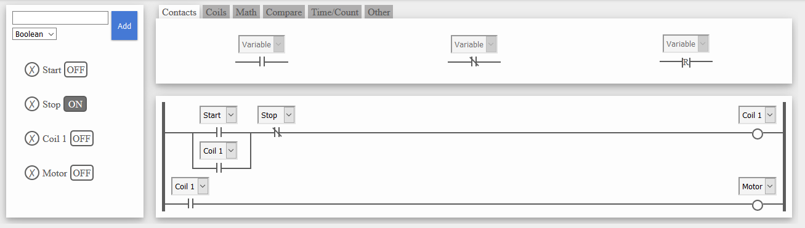

Using you mouse click the OFF symbol next to the start button.
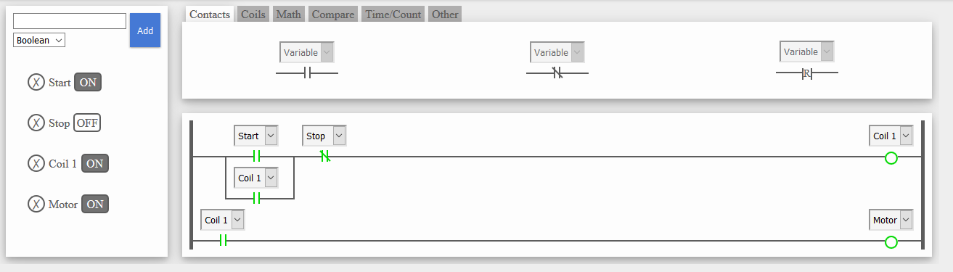
The start button will now display ON. The start contacts (Coil 1) will turn green to indicate that it is on. The motor will turn on through the normally closed contacts of the Coil 1 and the start button will be sealed by a contact off of coil 1.
Now turn OFF the start button by clicking the ON.
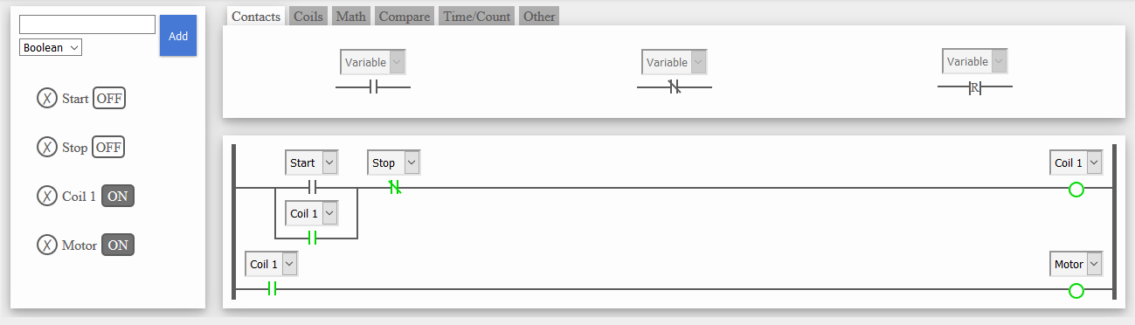
You will see that the motor remains on through the sealing contact in parallel with the start button.
Click the OFF next to the stop button.
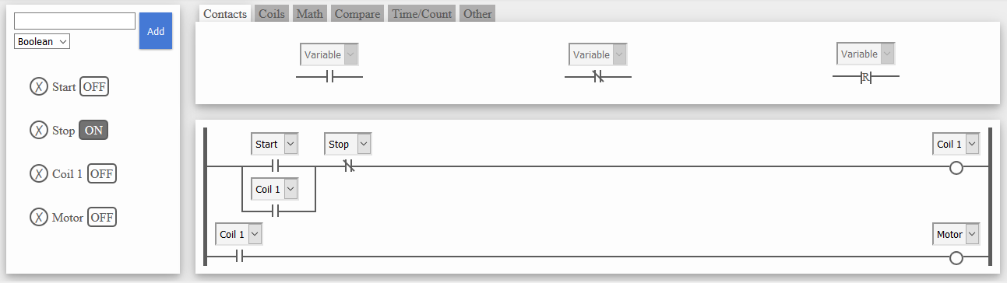
This opens the Normally Closed STOP contact, breaking the current path, and shutting off Coil one, which also breaks the seal contact (in parallel with the start button) and also breaking the path on the 2nd full rung, turning off the motor.

Using word’s Insert | Screenshot feature, capture your ladder logic below (again ensure that your initial are part of the Motor Name for credit):

Part two: Modify the above to allow a 2nd start button (Start2) to start the motor and a 2nd stop button (Stop2) to stop the motor. You should be able to do this by only modifying the 1st rung (and its branch rung(s))

Using word’s Insert | Screenshot feature, capture your ladder logic below (again ensure that your initial are part of the Motor Name for credit):

Answer the following questions:
Q1: What Boolean function is created by Start, Coil1 and Start 2 contacts?

Q2: What Boolean function is created by Stop and Stop2 contacts?

Q3: Using the FIRST ladder logic, and starting at the “Normal state” (ie both push buttons in their normal state), describe how the ladder logic starts (when the start button is pressed), how it remains running when the start button is turned back off (released) and how it stops the motor when the stop button is pressed and remains off when the stop button is release (turned off).

Instructions: Ensure you have put your name at the top of the lab handout. Added the TWO screen captures and answered all three questions. Submit via online file submission as a docx file. Due at start of next weeks lab.

